Apply filters to SQL queries

Project description
In this project, I acted as a security professional investigating potential threats and vulnerabilities within an organization’s systems. The organization maintained two important datasets: one containing employee information and another tracking login attempts. My primary goal was to use SQL queries with filters to analyze these datasets and uncover unusual patterns, failed login attempts, and employee groups requiring IT updates.
To achieve this, I applied different SQL operators such as AND, OR, NOT, and LIKE along with date and time filtering. For example, I identified failed logins that occurred after business hours, retrieved login activity for specific dates tied to suspicious events, excluded login attempts originating from Mexico, and isolated employees based on department and office location. These queries highlighted how SQL can be used as a powerful investigative tool to support cybersecurity monitoring, security audits, and IT operations.
This project demonstrates not only technical knowledge of SQL but also the ability to apply database skills in a real-world security scenario. By filtering large datasets down to the most relevant information, I was able to provide insights that could help prevent security breaches and ensure employee machines were updated according to policy.

Retrieve after hours failed login attempts
SELECT *
FROM log_in_attempts
WHERE login_time > '18:00' AND success = 0;
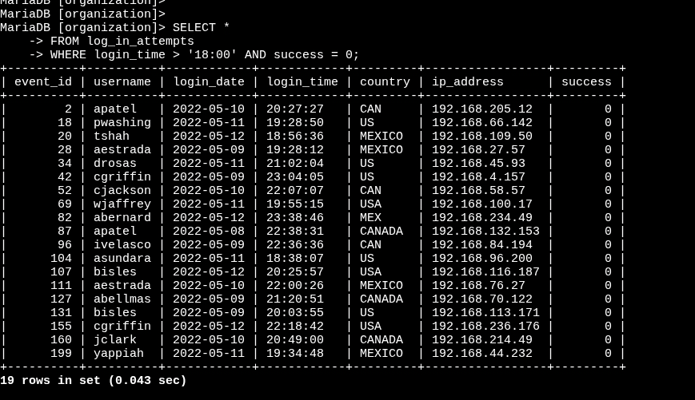
This query identifies all failed login attempts that occurred after 18:00, which is outside of business hours. These results help detect potential suspicious activity.
Result: 19 failed login attempts

- SELECT * → retrieves all columns from the table.
- FROM log_in_attempts → specifies the table being queried.
- WHERE → applies conditions to filter results.
- login_time > '18:00' → selects only login attempts after 6:00 PM.
- AND → combines conditions so both must be true.
- success = 0 → ensures only failed login attempts (where 0 = failure) are retrieved.

Retrieve login attempts on specific dates
SELECT *
FROM log_in_attempts
WHERE login_date = '2022-05-08' OR login_date = '2022-05-09';
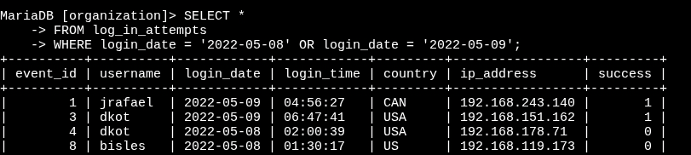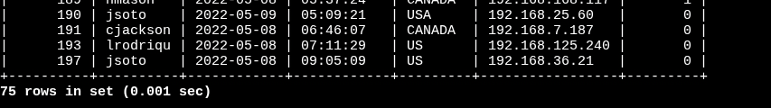
This query retrieves all login attempts from 2022-05-08 and 2022-05-09, dates linked to a reported suspicious event. Filtering by specific dates narrows the investigation to the relevant timeframe.
Result: 75 login attempts

- login_date = '2022-05-08' → filters records that happened on May 8, 2022.
- OR → means either this condition OR the next one can be true.
- login_date = '2022-05-09' → filters records from May 9, 2022.

Retrieve login attempts outside of Mexico
SELECT *
FROM log_in_attempts
WHERE NOT country LIKE 'MEX%';
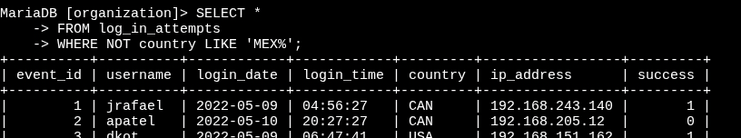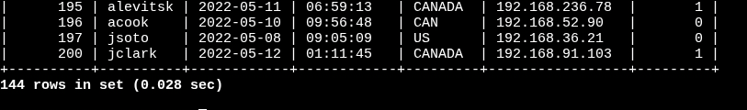
This query excludes all login attempts originating from Mexico (values like 'MEX' or 'MEXICO'). Using LIKE 'MEX%' ensures both variations are captured and excluded. The remaining results show login attempts from other countries.
Result: 144 login attempts outside of Mexico

NOT → excludes rows that match the condition.

country LIKE 'MEX%' → matches country values that start with “MEX” (like “MEX” or “MEXICO”).

Retrieve employees in Marketing
SELECT *
FROM employees
WHERE department = 'Marketing' AND office LIKE 'East%';
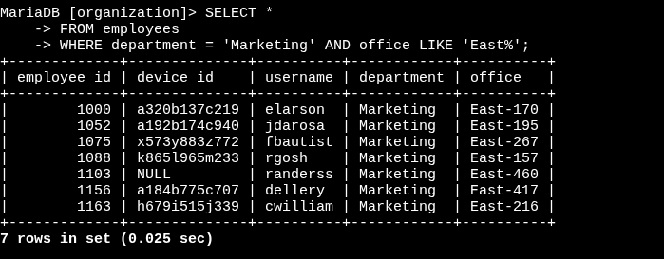
This query retrieves employees who belong to the Marketing department and are located in offices within the East building. The LIKE 'East%' filter captures all office numbers beginning with 'East'.
Result: First employee returned → elarson

- department = 'Marketing' → filters for employees in the Marketing department.
- AND → requires both conditions to be true.
- office LIKE 'East%' → selects only employees whose office value starts with “East” (such as East-170).

Retrieve employees in Finance or Sales
SELECT *
FROM employees
WHERE department = 'Finance' OR department = 'Sales';
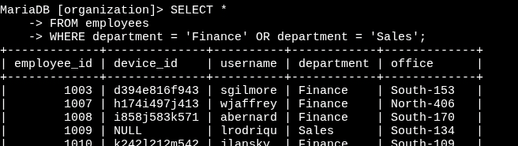
This query pulls employees from both the Finance and Sales departments. The use of the OR operator ensures that records from either department are included.
Result: First Sales employee returned → lrodriqu

- department = 'Finance' → filters for Finance employees.
- OR → allows either condition to be true.
- department = 'Sales' → filters for Sales employees.

Retrieve all employees not in IT
SELECT *
FROM employees
WHERE NOT department = 'Information Technology';
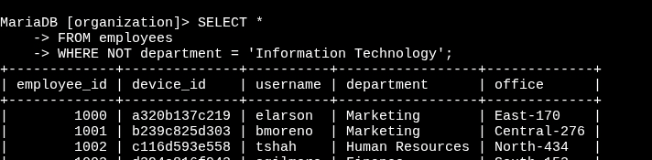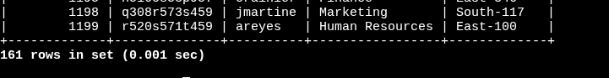
This query retrieves employees from all departments except IT. The use of NOT excludes those in 'Information Technology,' since they already received the required updates.
Result: 161 employees not in IT

- NOT → excludes rows that meet the condition.
- department = 'Information Technology' → specifies employees in IT.

Summary
Through this project, I demonstrated how SQL queries can be applied to real-world security and IT management challenges. By filtering datasets containing employee information and login activity, I was able to uncover failed login attempts, isolate suspicious activity by time and date, and identify groups of employees who required security updates. These targeted queries transformed large, complex datasets into clear, actionable insights for both incident response and system maintenance.
The activity also highlighted the versatility of SQL filtering techniques. I applied logical operators such as AND, OR, and NOT to combine or exclude conditions, used LIKE patterns to detect specific text values, and incorporated date and time filters to focus on precise events. Each query illustrated a different investigative use case, whether it was identifying login attempts outside of business hours, isolating records outside a geographic region, or narrowing results to specific departments within the organization.
Overall, this project shows how SQL can play an essential role in cybersecurity investigations, security audits, and IT operations. By mastering filtering techniques, I can quickly extract the data needed to evaluate risks, detect unusual activity, and ensure that organizational systems remain secure and up to date. These skills are critical in modern enterprises where timely analysis of data can prevent security incidents and support proactive system management.

